Experiment 7 – 5G NR Frame Structure and Subcarrier Spacing
Aim
To study a simplified 5G NR resource grid, compare subcarrier spacing and slot duration, and identify basic downlink/uplink resource assignments.
Procedure
- Define a resource grid with 24 subcarriers and 14 OFDM symbols.
- Assign symbols 1–10 to simplified downlink and symbols 11–14 to simplified uplink.
- Plot the resource grid.
- Plot slot duration for SCS values 15, 30, 60, 120 and 240 kHz.
- Inspect the downlink/uplink assignment plot and explain gNodeB and RRC roles.

Objective – 1: Generate / Inspect a Simplified 5G NR Resource Grid
MATLAB PROGRAM;
clc; clear; close all;
Nsc = 24; Nsym = 14;
gridData = zeros(Nsym,Nsc);
gridData(1:10,:) = 1; % Simplified downlink
gridData(11:14,:) = 2; % Simplified uplink
figure; imagesc(gridData); grid on; colorbar;
xlabel('Subcarrier index'); ylabel('OFDM symbol index');
title('Simplified 5G NR Resource Grid');

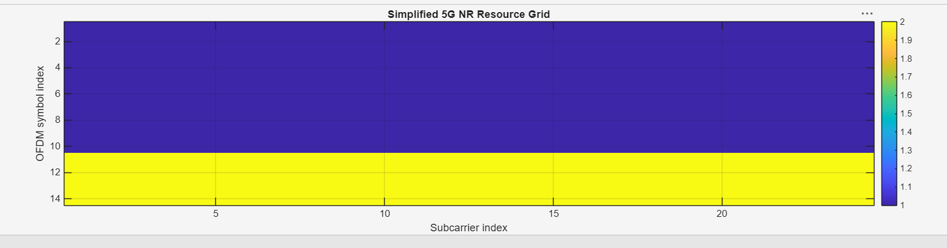
Objective – 2: Compare SCS and Slot Duration
MATLAB PROGRAM
clc; clear; close all;
scs = [15 30 60 120 240]; mu = 0:4;
slot = [1 0.5 0.25 0.125 0.0625];
figure; plot(scs,slot,'o-','LineWidth',2); grid on;
xlabel('Subcarrier spacing (kHz)'); ylabel('Slot duration (ms)');
title('SCS versus Slot Duration');
figure; bar(mu,scs); grid on;
xlabel('Numerology index'); ylabel('Subcarrier spacing (kHz)');
title('5G NR Numerology');

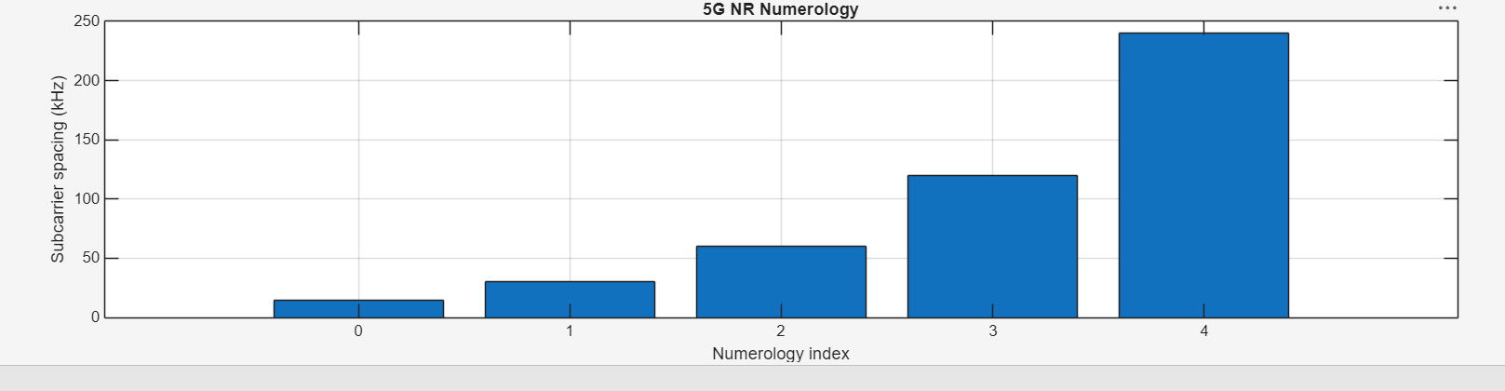

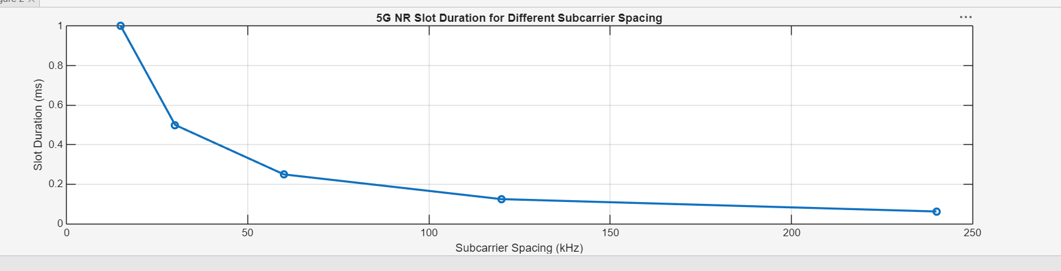
Objective – 3: Identify Basic DL and UL Resource Assignments
MATLAB PROGRAM
clc; clear; close all;
symbols = 1:14;
DL = [ones(1,10) zeros(1,4)];
UL = [zeros(1,10) ones(1,4)];
figure; plot(symbols,DL,'o-',symbols,UL,'s-'); grid on;
xlabel('OFDM symbol index'); ylabel('Allocation status');
legend('Downlink','Uplink'); title('Simplified DL/UL Assignment');

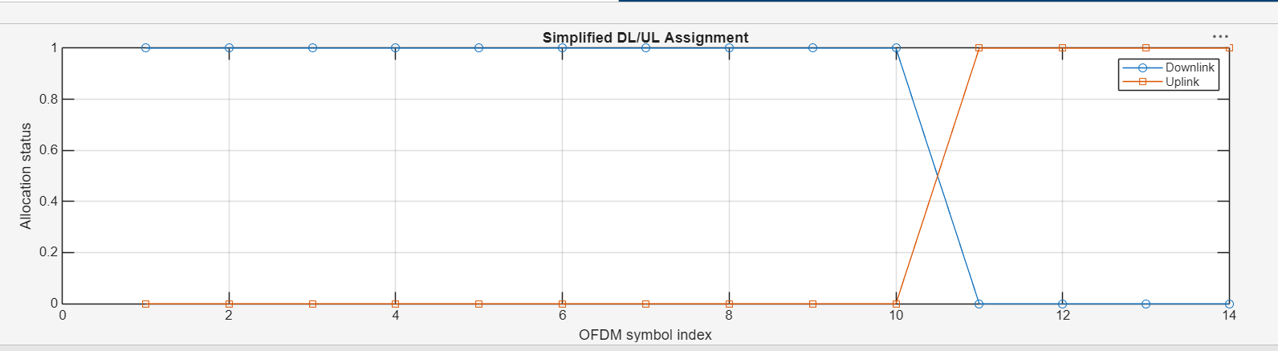
Result
The simplified resource grid and DL/UL allocation were plotted. Slot duration decreases as subcarrier spacing increases. A normal cyclic-prefix slot contains 14 OFDM symbols in the model.

